WHAT DO THEY LIKE ?

HE / SHE LIKES

HE/SHE DOESN’T LIKE
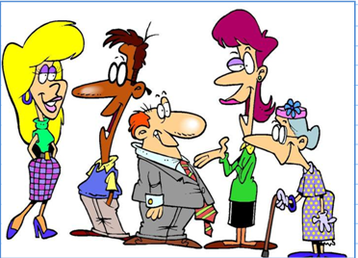

- Have a look at the chart
HOBBIES | EVA | TOM | JOE | TINA | MISS TATE
READING
PLAYING GOLF

READING COMICS
GARDENING

PHONING FRIENDS
WATCHING

- And now make up sentences : Eva likes …….and she likes ……..but she doesn’t like ………………………

