

PRESENT SIMPLE

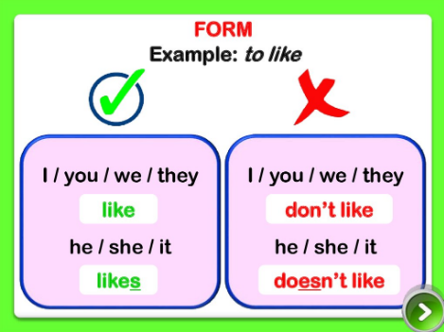

Questions

|  |  |  |  |
| --- | --- | --- | --- |
| DO | **I /YOU/WE / THEY** | LIKE | READING ? |
| DOES | HE / SHE / IT | LIKE |

* Je remarque l’……………………………………de ………………….qui devient ……………………à la ………………………………………………………….C’est un …………………………………..qui permet au verbe …………………………..de se CONJUGUER au ………………………………………………………………………………