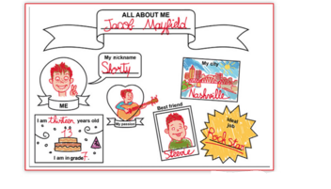

What is his name ?
Waht is his nickname ?
How old is he ?
What is the name of his best friend ?

