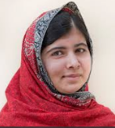

Malala YOUSAIFZAI

1.Tell her story :
Be born in Pakistan in 1997 .
When be a child :become the defender of girl’s education in Pakistan .
The Talibans cannot stand it : a gunman shoot at her on her way back home.
He hurt her so much that she almost die .She finally survive and go on talking about the girls’s rights to education .She give a speech at the United Nations nine months after her attack: she say the Talibans think she would stop ;
She become the youngest person to receive the Nobel Prize

2. What impact has she left ?

Become the Pride of Pakistan / Manage to continue the fight / Write books because the Talibans fear education / come to an unparalleled achievement / from a personal point of view , fear : to go away / Strength and motivation be born.

